BREAKFAST CHATTER
Weekly Bulletin of Rotary Club of Kathmandu Mid-Town
District 3290 Volume No. 15/43 for #785 May 20, 2005
www.rotarymidtown.org.np
MAY IS THE DISTRICT ASSEMBLY MONTH
☺ ☺ ☺ *** ??? *** ☹☹ nobody’s special day! ☹☹ *** ??? *** ☺ ☺ ☺
*********MEETINGS & ACTIVITIES*******
DATE | ACTIVITY | SUBJECT
20 MAY | AMOD MANI DIXIT | DO THIS BEFORE TOMORROW’S EARTHQUAKE
23 MAY | BOARD MEETING | SAROJ SHRESTHA HOSTING
27 MAY | GOPAL KAKSHAPATI | CENTENNIAL FELLOWSHIP MEETING
03 JUN | KRISHNA BHATTARAI | HRDC RH PILOT PROJECT
10 JUN | DAVID WARD | TOPIC TO BE ANNOUNCED
16 JUN | BOARD MEETING | ARUN SHERCHAN HOSTING
17 JUN | DAVID SOWERWINE | FOOTLIGHTS FOR THE HIMALAYAS
24 JUN | CLUB ASSEMBLY | LAST BUT NOT LEAST
01 JUL | R M-T BOARD | INSTALLATION CEREMONY
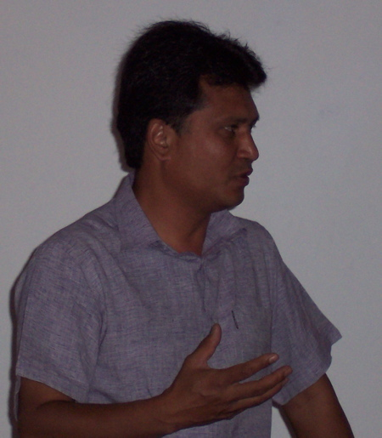
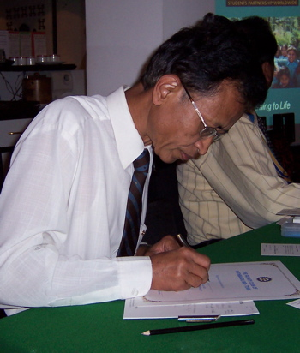
<<Ravindra Shakya and Rachel Booth from Students Partnership Worldwide joined us on the 13th. Ravindra described the ‘Green Clubs’ they have formed: “school-based groups of students who undertake activities for their own personal development and that of their communities”. Members identified several areas in which there are shared goals & the potential for cooperation. *** Coming Friday our speaker will be Amod Mani Dixit. The subject – how to prepare for the inevitable big earthquake -- is of life-or-death importance for all our families. Spouses will be most welcome to hear this talk, and Rotarians are encouraged to ‘prepare now’.

RR @ Worrk
Hope to see you on Friday morning. YIR…David

